

**SILVER CLASSIC OPEN SHOW**

NCWHA SANCTIONED SHOW ~ Western Day Sunday, Sept. 10th, 2023 ~ Judge: Karla Kegley

8 A.M. Rain or Shine ~ 7510 Deer Road Custer, WI 54423

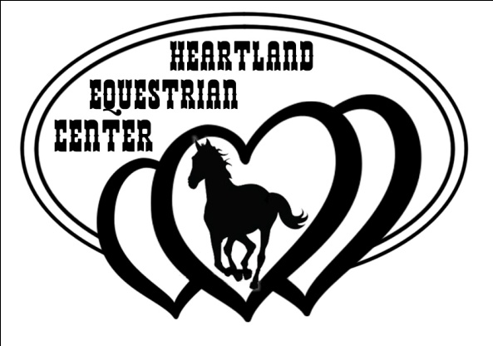

***Food Available on Grounds***

***At Heartland Café***

***Daily & Weekend HighPoints Awarded!***

**AGE DIVISION:** (as of January 1st)

**Tiny Tot:** 10 & Under **Children:** 13 & Under

**Intermediate:** 14-18 **Senior:** 19 & Over

**Senior Senior**: 40 & Over (cross entry into Senior is permitted)

**Open:** All Ages

* *\*\* Non-NCWHA Approved Class*
* Pre-Registration (Online JotForm) is available
* $6 Office fee per horse/rider combo
* *\*\*\*Tiny Tot Leadline class fees ONLY, NO office fee\*\*\**
* $7 per class
* $5 High Point entry Per Day
* Grand & Reserve Daily Overall HighPoint Belt Buckles awarded
* Daily High Point awards for Tiny Tot, Novice, Children’s, Intermediate, Senior, & Senior Senior (Choose only one High Point category)
* All Classes count towards High Point Awards (in an event of a tie, showmanship will be the tie breaker)
* Belt Buckles for Weekend Overall Grand & Reserve High Point
* Ribbons for 1st-6th
* **Jump out fee $5/per horse**
* Stalls available day $25/night $30
* Bedding $9/bag or bring your own
* Camping per night $25
* No refunds for scratched classes. Scratch 2 classes ahead please
* #Open Novice: see registration booth for Novice eligibility
* Helmets are required for all riders under 18 years old
* Show clothes and proper tack is required, bling is not required
* Must be at least 18 years of age to handle a stallion
* All decisions of judges are final
* Heartland Equestrian Center has the right to combine classes
* Copy of current negative Coggins is required to the show office
* No arrival before 4pm on Friday
* Heartland Equestrian Center, the employees and volunteers will not be held responsible for any loss, theft, or injury to participants, spectators, or animals
* All dogs must be on a leash

**STALL RESERVATION: Mark @ 715-323-3666**

**SHOWBILL & NCWHA RULES: Taylor @ 715-305-0216**

1. 2 & Under Halter
2. Horse Type Halter Mares All Ages
3. Horse Type Halter Geldings/Stallions All Ages
4. Pony Halter (56” & Under) All Ages
5. Mini Horse @ Halter**
6. English Type Halter **
7. Western Type Halter**
8. Color Breed Horse at Halter All Ages**

**Grand & Reserve Championship Halter**

1. Senior Senior Showmanship
2. Senior Showmanship
3. Intermediate Showmanship
4. Children’s Showmanship
5. Tiny Tot Showmanship
6. Tiny Tot Leadline Showmanship (7 & Under)**
7. #Open Novice Showmanship
8. Open Showmanship
9. **In-Hand Trail (All Ages)

**15 Min Break – Open Arena**

1. Open W/T Bareback Horsemanship
2. Open Bareback Horsemanship
3. Ride-A-Buck (Bareback)**
4. Tiny Tot Leadline W/T EQ/HMS (7 & Under)
5. Tiny Tot W/T Western Pleasure
6. Tiny Tot W/T Horsemanship

**30 Min Lunch Break – Open Arena**

1. Senior Senior W/T Western Pleasure
2. Senior W/T Western Pleasure
3. Intermediate W/T Western Pleasure
4. Children’s W/T Western Pleasure
5. #Open Novice W/T Western Pleasure
6. Open W/T Western Pleasure
7. Open Sr. Horse Western Pleasure (6 & Over)
8. Open Jr. Horse Western Pleasure (5 & Under)
9. Open W/T Pony Western Pleasure (56” & Under)**
10. Pony Western Pleasure (56” & Under)
11. Senior Senior Western Pleasure
12. Senior Western Pleasure
13. Intermediate Western Pleasure
14. Children’s Western Pleasure
15. #Open Novice Western Pleasure
16. Open Western Pleasure
17. Open W/T Western Horsemanship
18. Senior Senior Western Horsemanship
19. Senior Western Horsemanship
20. Intermediate Western Horsemanship
21. Children’s Western Horsemanship
22. #Open Novice Western Horsemanship
23. Open Western Horsemanship
24. Open Western Disciplined Rail
25. Open W/T Egg & Spoon
26. Open Egg & Spoon
27. Open W/T Trail
28. Open Trail
29. Open Ranch Riding
30. Open Ranch Rail
31. Open Reining